Document 526
POST IMPLEMENTATION REPORT

CHAPTER: PORTLAND PROFESSIONALS
COUNTRY: HAITI
COMMUNITY: LES ANGLAIS
PROJECT: WATER IMPROVEMENTS

PREPARED BY
Travis Hultin
Kim Slack
Aimee Lavarnway
Matt Hewitt
Lisa Peffer
Jennifer McClure
Carolyn Shapiro

July 2010

ENGINEERS WITHOUT BORDERS-USA
www.ewb-usa.org

Post Implementation Report Part 1 – Administrative Information

1.0 Contact Information

 | Name | Email | Phone | Chapter
Project Lead Water | Carolyn Shapiro | shapiro@cohabitable.com | 503-464-6433 | Portland Pros
Project Lead Sanitation | Kim Slack | kimslack@ewbportland.org | 971-678-9852 | Portland Pros
Chapter President | Steve Adams | steveadams@ewbportland.org | 503-682-4960 | Portland Pros
Engineering Lead | Travis Hultin | Travis888@verizon.net | 503-492-3259 | Portland Pros
Public Health Lead | Kay Mattson | kdmattson@hotmail.com | 503-522-3526 | Portland Pros
Health and Safety Officer | Jennifer McClure | Jennifer.mcclure@gmail.com | 360-433-7286 | Portland Pros
Asst. Health and Safety Officer | Lisa Peffer | Lisa_peffer@yahoo.com | 503-282-6521 | Portland Pros
Community Contact | Etienne Francois | Etiennelth01@yahoo.fr | 509 37126729
Tout Bagay Trip Support Lead | Laurent Auguste | toutbagaygroup@gmail.com | 509 34387090

2.0 Travel History

Dates of Travel | Assessment or Implementation | Description of Trip
Jan 29 – Feb 8, 2009 | Assessment/Partial Implementation | Seven team members conducted health and water system assessment and water system repairs.
June 18 – July 4, 2009 | Implementation | Eight team members worked on significant repairs to the system to bring full flow back to the storage reservoir and completed some assessment activities.
June 3 – 13, 2010 | Water Implementation, Sanitation Assessment | Four team members completed chlorinator installation and supporting activities, 2 team members conducted sanitation assessment activities.

3.0 Travel Team

Name | Email | Phone | Chapter | Student or Pro
Travis Hultin | Travis888@verizon.net | 503-492-3259 | Portland Pros | Pro
Kim Slack | kimslack@ewbportland.org | 971-678-9852 | Portland Pros | Pro
Matt Hewitt | HewittMP@cdm.com | 303-619-0884 | Portland Pros | Pro
Aimee Lavarnway | ael@shanwil.com | 503-679-5014 | Portland Pros | Pro
Jennifer McClure | Jennifer.mcclure@gmail.com | 360-433-7286 | Portland Pros | Pro
Lisa Peffer | Lisa_peffer@yahoo.com | 503-282-6521 | Portland Pros | Pro

4.0 Safety

4.1 Safety Incident Reports
None

5.0 Budget

5.1 Cost

Expenses | Total Cost
Airfare | $4,620
On Ground | 10,520
Materials | 3962
Other | 440
Total | $19,542.

6.0 Project Location

Longitude: 18.3
Latitude: -74.2

A site vicinity map of Les Anglais, Haiti is included as Figure 1.

Figure 1. Site Vicinity Map. Les Anglais lies in the Southwest corner of Haiti.
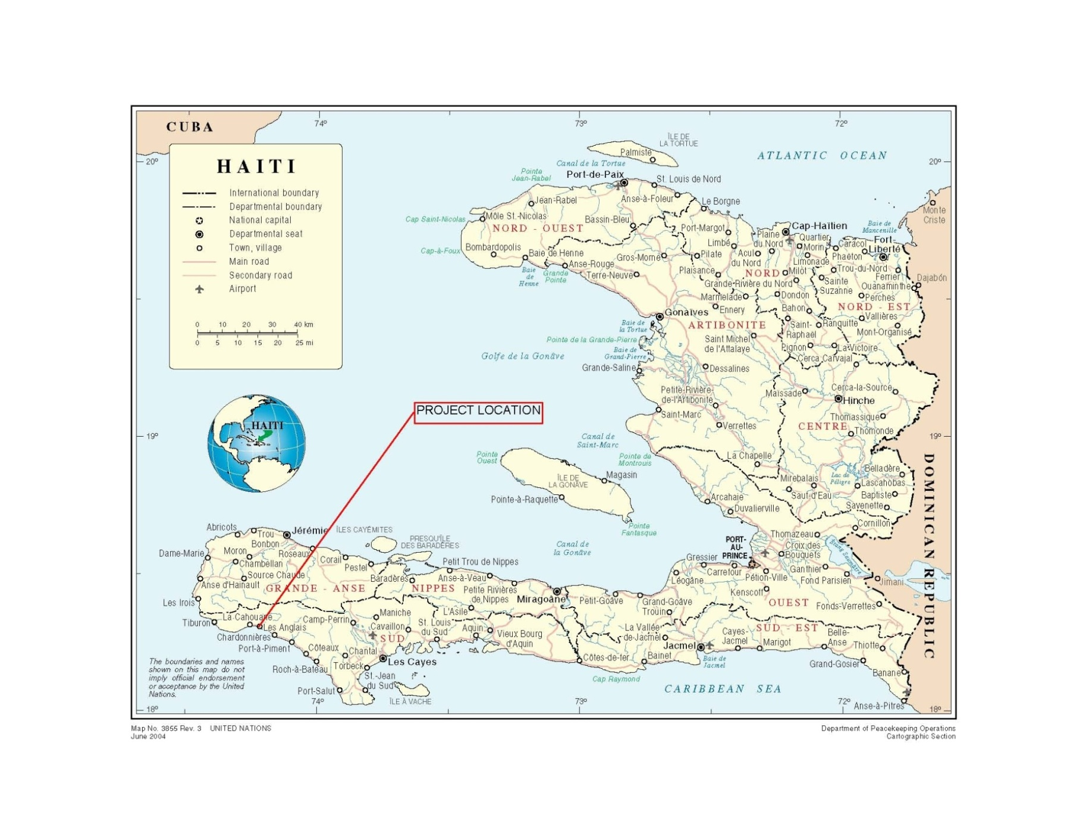Post Implementation Report Part 2 – Technical Information

1.0 INTRODUCTION

This report describes activities completed during the June 2010 EWB Les Anglais program field trip to continue to implement improvements to the community water system. Assessment work for the new EWB Les Anglais sanitation team was also completed and will be described in a separate post-assessment report.

The primary objectives of the water team implementation trip were:
- Install a chlorine tablet feeder to treat water from the Basin Simbe Reservoir
- Train community volunteers on safe operation and maintenance of the chlorinator
- Check on repairs that the community completed on the water system without the EWB team
- Gather information on the 6 community wells, including water quality data, and information to support future training in hand pump maintenance
- Gather configuration data on the Caiman system to support design of a means to reduce system pressure, and to support design of a chlorine tablet feeder for its storage reservoir.
- Meet with representative from Sofitraining, a Haitian partner with IFC-World Bank, to assist her in scoping financial management training for the Les Anglais water boards.

2.0 PROGRAM BACKGROUND

The Les Anglais project began when the Portland Professional EWB chapter was approached by the Portland-based church group Our Savior’s Lutheran Church (OSLC) with a request to assist the community of Les Anglais. OSLC has been doing missionary work in Les Anglais for about 20 years. They sponsored a medical clinic in Les Anglais in 2006 and came away from that with a strong impression that many of the illnesses they were treating were related to contaminated drinking water, and that one way to significantly improve the health of the community was to address the drinking water problem. Two engineers from the chapter traveled to Les Anglais in March 2008 with OSLC on an exploratory trip to gather information. Summary information from the trip included:

- • Les Anglais is served by two separate source springs, the Caiman and the Basin Simbe. The existing distribution system consists of a series of above and below ground pipes that convey water several miles from the springs to the town. People collect their drinking water from hundreds of taps located between the springs and the town. The system serves an estimated 12,000 people, although population information was inconsistent. Over the years the system has deteriorated many people have lost access to water. The hurricanes last fall destroyed sections of main lines and ultimately stopped flow of all water to Les Anglais town center.
- • The water system is 20 years old and was operational in early 2008, but had some maintenance issues that reduced capacity, enabled contamination to infiltrate the system and left the system vulnerable to future damage. Since the storms of 2008 the system was damaged further. It is not usable without considerable repairs.
- • Both source springs are contaminated with fecal coliform, likely from animal waste and an obvious lack of latrines across the community.
- • People walked about 15 minutes to a working tap on average but the community water could stop flowing several months of the year during the dry season. During that time people got water typically from whatever surface source that could be found.
- • The medical clinic is staffed but seems to lack basic medicines, and has no water or power.
- • The Les Anglais water board and mayors are supportive and very willing to work with an engineering team.

Based on findings from the March 2008 exploratory trip and ensuing discussions, the Portland Professional EWB chapter agreed to pursue a formal EWB Program to pursue water improvements in Les Anglais. The Les Anglais project team consists of engineers with backgrounds in civil, mechanical, environmental, electrical, agricultural, geotechnical, and transportation engineering, and public health professionals with backgrounds in water, sanitation and hygiene in international health, nutrition, and evidence-based health policy.

For the past two years the EWB team has been working with our contacts in Les Anglais and in New York, New Jersey, Miami, and Port-au-Prince, to find the best approach for improving the community’s drinking water. This has required considerable flexibility to address serious damage to the community water system from the 2008 hurricanes and subsequent flooding in Les Anglais, and the significant population increase in Les Anglais caused by the Jan 12, 2010 earthquake in Port-au-Prince.

During the course of our work community leaders in Les Anglais have repeatedly asked for assistance in improving sanitation in Les Anglais. Our baseline community health assessment confirmed a significant lack of access to latrines for the majority of families surveyed. In 2010, a decision was made to begin a sanitation project for Les Anglais that became an official EWB project April, 2010.

3.0 TRIP DESCRIPTION

The following paragraphs are a daily log of the June 2010 water improvements implementation trip:

Thursday, June 3
Travel team departs for Haiti. Travis departs from Seattle while the rest of the team departs from Portland. Due to thunderstorms in Miami, Matt and Travis are delayed in Dallas Thursday night. Aimee, Jennifer, Lisa, and Kim arrive late in Miami.

Friday, June 4
Morning: Aimee, Kim, Lisa, Jennifer arrive at PAP as scheduled at 8:20 am. Picked up by Edouard, Joseph, Laurent, and Ty; lots of traffic. Matt and Travis not scheduled in PAP until 3:45 pm. In the meantime, Aimee, Lisa, Jennifer, and Kim stay at Laurent’s parents’ house until Travis and Matt arrive. Review parts inventory, organize luggage, review sanitation assessment workshop notes and work plan. Kim and Edouard go to Petionville to purchase cell phone for team to use during trip.

Afternoon: Travis and Matt arrive at 3:45 pm, Travis’ luggage did not arrive. Too late to travel from PAP by the time Travis and Matt arrive, so team decides to leave early Saturday morning by car; stay the night in PAP at Laurent’s parents’ house, one of the safe houses defined in the health & safety plan.

Saturday, June 5
Morning: Tout Bagay and EWB team leaves the Auguste house at 5:30 am.

Afternoon: Arrive in Les Anglais at 2pm. Lunch at MEBSH church with Etienne, then took a tour of the town center area, mapped streets that were missed on previous trip. Heavy rain in afternoon. Review work plan with Etienne, and discuss scheduling of meetings for sanitation assessment, develop plan for Sunday.

Sunday, June 6
Morning: Breakfast at 7am. Safety Meeting. 8am, whole team takes chlorinator enclosure up to the Basin Simbe reservoir. Lo and Ty leave after chlorinator enclosure left at reservoir, Ty has to catch flight back to Miami. Rest of team walks up to Basin Simbe spring box to inspect repair of sedimentation chamber. Repair looks great, Altrix and team did a great job. While there, the team noted a large, relatively flat area just downstream of the spring/sed box area where a mixing tank could be constructed if a chlorinator seems like an appropriate approach for the rest of the Basin Simbe line in the future. Walk back to MEBSH church along system mapping path and viewing additional repair work completed by locals, as well as points of concern along the system. Lunch at 12.

Afternoon: Planned to have kick-off meeting with mayors, water board, plumbers, facilitator trainees, chlorinator operator trainees at 2pm, but big rainstorm rolled in and we had to postpone the meeting until after the rainstorm. EWB team decides to shower in the rainstorm, under building downspouts. Then team walked to the river to observe storm runoff in heavy rain. Residents highly entertained by the sight of “blancs” running in the heavy rain. During “rain walk” saw old, possibly colonial, stone reservoir-like structure behind houses. Heavy rains caused flooding in majority of town streets and some yards, street flooding subsided fairly quickly after rain stopped. Eleven invitees of kickoff meeting arrived at hospital pavilion after the rain subsided. At 6:00pm the team had a “mini-kickoff meeting” with some facilitator trainees, operator trainees and the hospital administrator. Looked at the submersible pump in the well at the clinic and at the water tank and broken piping entering the clinic. Took a sample of water coming out of the tank to test for bacteria.

Monday, June 7
Morning: Travis, Matt, Lo, Edouard, Mr. Laurent, and community work crew to Basin Simbe reservoir to begin chlorinator installation. Local labor completed trenching for chlorinator branch line. Aimee, Jennifer, Lisa take community-led resources tour of town center area and Lagoon, Altrix and Julio guide and Joseph translates. Spoke with dentists, observed several latrines, and Altrix showed us a relatively new reservoir (dated 2005) on the Basin Simbe line that we didn’t know about, which is no longer functional (although the people we talked to didn’t seem to know why it wasn’t used). Kim started chlorine demand experiment, delivered tools as needed from LA to reservoir site.

Afternoon: Chlorinator install continues. Chlorinator team completes dry fit of chlorinator assembly and repair of existing valve assembly and line feeding reservoir. Aimee meets with Jan Guttwein (MEBSH) to gather information about wells and pumps. Jan says that the above-ground portion of the pumps are designed and manufactured by his brother in Indiana and the below-ground portion is purchased from a foundry (possibly on the east coast?), but he doesn’t know much about the details. He said that Enoc (the Haitian driller) manages any repairs and that he is not interested in having the communities take responsibility for maintenance (beyond collecting fees to pay for the repairs). Takes him to visit Basin Simbe chlorinator installation and spring since he was unaware of the existing distribution systems. Lisa, Jennifer, Kim go to Health Clinic for facilitator training; Joseph translated. Etienne arranged for refreshments and organized meeting. Training started late due to food handouts at the health clinic. People were being given food and then sitting out front and selling it in the outdoor meeting area. Robert told them to leave so we could have our meeting; said they should be eating the food handouts, not selling it. After facilitator training, Lisa, Jennifer, Joseph go to school for sanitation survey. Kim returns to MEBSH compound for continuation of chlorine demand experiment. Aimee and Kim take bacteria test samples from wells 1, 2, and 3. Buckets of chlorine tablets retrieved from Etienne’s storage shed to the church; the buckets were not sealed, one bucket was only half full, and many remaining tablets were broken. Discuss options for getting new tablets, but due to logistical constraints, plan to use the old ones for the week and then figure out a fresh supply after the trip.

Tuesday, June 8
Morning: Altrix dispatched to BS reservoir to perform masonry work, specifically to construct pedestals for chlorinator and pipe supports. Chlorinator operator training at the Health Clinic pavilion. Kim led training with Travis, Matt, Aimee present and Edouard translating. Three primary operators and three backup operators were identified by Etienne and Robert for the job. Water team had hoped to dose the reservoir in the morning but it was not yet emptied. Changed plan to dose in the afternoon when it is mostly drained. Mr. Jean Marie was also present for only the beginning of the meeting. Lisa, Jennifer completed another school survey and continued community-led resources tour with Joseph. Kim went to meet with Health Clinic administrator and two nurses to provide information for treatment of potential chlorine hazards. While there she ran into CRS worker, Felix, from Port-a-Piment. Had a rushed conversation with him and learned that Health Agent program (Cols Vols) was started by CRS about 20 years ago. Felix and Kim exchanged contact information.

Afternoon: Altrix completes masonry work at BS reservoir. Lisa, Jennifer met with facilitators at 2pm to prepare for the 3pm sanitation workshop with the informal community leaders. After 3pm no one was showing up for the meeting so Etienne had to go and remind everyone to stop what they were doing and come to the meeting that he had already told them about. During introductions, Kim was asked many specific questions about the chlorinator and water quality, as well as plans to connect the abandoned taps in town from Caiman system. Aimee, Kim, Travis, Matt visit Etienne’s office to pick up tools and parts needed for chlorinator installation, Etienne shows us the chickens and explains program and current feed issues. Question of whether food bought from PAP (imported from the Dominican Republic) is really necessary for feeding the chickens so that they lay eggs. Aimee, Matt, Travis continue to walk up to the newly-found reservoir along Rue Nationale, apparently connected to BS system, noting pipe breaks along the roadside. Markings indicated that it was built by CRS in 2005. It is totally defunct (although we are told that it works). Kim, Travis, Matt, Aimee, operators, and M. Laurent then head up to reservoir for dosing the reservoir. Reservoir dosed with 0.77 kg granular chlorine at 4:30 pm, to bring Cl concentration up to ~4 ppm, reservoir isolated for filling and mixing overnight. Stopped to get bacteria sample at Digue well on the way back to the church. Broke the sample vial for Well 2 after it appeared to be positive, but before the 24-hour incubation period was complete; resampled with both types of tests.

Wednesday, June 9
Morning: Travis, Matt, Kim head to reservoir to check Cl concentration before opening discharge line. Concentration was 1.5 ppm so it was ok to release water to distribution lines. Outlet was opened and allowed to drain. Inlet remained closed. Travis and Matt stayed at reservoir to complete installation, while Kim heads back to town to join Jennifer and Lisa for meeting with mayors, casecs, and asecs (neighborhood leaders). Aimee and Edouard meet with Jean Noel in the morning, check out Wednesday market and Julio’s shop for material availability and costs (resources for latrines and enclosure walls), visit another chicken coop, complete initial chlorine monitoring of BS system at identified sampling points, meet up with team at reservoir. Found to be 1.0 ppm at the first community tap and 0.5 at last community tap, 2-3 hours after measuring 1.5 at reservoir.

Afternoon: Matt, Aimee, Lisa, Jennifer head to Caiman side to survey reservoir for chlorinator and pressure reduction assessment, school survey and resources tour for sanitation. A large group of people, mostly associated with the foundation, led by the vice Mayor and including Enock (Caiman plumber), are gathered expecting an involved sit-down meeting. Laurent took over the meeting and told them that we needed to talk to whoever was in charge, and then discussed the background of the foundation with the Vice-President. Enock was also at the meeting and seemed to be wondering if we were intending to meet with him. We had informed Michelin (a person who was at the chlorinator operator training and said that he was a Caiman plumber) that we wanted to take more detailed measurements on that system and had made an appointment to do that with him. We also asked him to invite Enock and he said he would; however, Michelin reportedly does not actually work on the east side of the river and Enock was never notified. Following the meeting, several of the participants, including Enock and his assistant, went to the reservoir and spring to complete the assessment and discuss any other issues with the system. Took flow measurements of the reservoir overflow, detailed dimension measurements of all structures, observed hairline cracks in the reservoir walls, collected water sample for bacteria test, saw more boulder movement in drainages since last visit. Unable to complete walk of entire system or a visit to the Verone well due to sunset. Travis and Kim go to BS reservoir for more chlorine testing and dosing, working more on chlorinator installation. Repeated dosing of 0.77 kg granular chlorine at around 5pm. Vice-mayor Mme. Exile joined us for dinner and told us about some of the programs she has been helping to organize. We gave her some information on the local microfinance company and a Portland-based fuel briquette press, which she said she was interested in trying. Bacteria samples from well 2 complete; both types of tests are positive.

Thursday, June 10
Morning:
Laurent leaves Les Anglais very early in truck to pick up Madame Michaelle Fortune (Sofitraining) in Port Salut. Kim, Matt, and Travis head up to reservoir to finish work on chlorinator. Chlorine concentration after previous night’s dosing was found to be 1.2 ppm. Tablet feeder cannot yet be placed online due to some leakage around chlorinator inlet and outlet pipe connections. Kim heads over to a farm plot next to the reservoir, where an agronomist by the name of Jean Franck Constant is teaching local farmers how to graft mango trees to grow more valuable mangoes. Edouard and Kim photo-document for future sharing with Jerry Walton. Back at chlorinator Kim begins hands-on chlorinator training with operators. We are all expecting Laurent and Michaelle to return by 11 but they are running late. Etienne arranges for those who were called for the meeting with Michaelle to have lunch at the church compound, nonetheless they wait until almost 2pm, when they finally arrive in Les Anglais.
Aimee meets with Jean Noel at Julio’s shop to train him how to download and email photographs to Dominique. Unfortunately the internet was extremely slow and the yahoo mail site seemed to be down, so they never got to access his email account. Saw a class of ~10 high school aged students drawing houses in Paint on the computers in the cyber café while there.
Lisa and Jennifer complete sanitation assessment facilitator wrap-up training.

Afternoon: Meeting with Michaelle and water board members. Representatives from the Chardonnieres water board and other local organizations also attended (42 people, total). Jennifer, Lisa, Aimee and Joseph attended this meeting in shifts as other last minute trip tasks were completed around the church compound. The meeting appeared to go well; people were interested, organized, and active. Michaelle told them her phone number at the end and everyone saved it in their phones. Because the meeting with the sanitation officer and maintenance workers was never arranged, the vice president of the Foundation helped Lisa by setting up a private meeting with a maintenance worker that he knew. Jennifer measured the proper chlorine dosing for the Health Clinic tank, so that it can be cleaned once the pipes are repaired and a cover has been placed on the tank (testing of the water coming down from the tank showed bacterial contamination, which is currently assumed to be from the tank and pipes, not the well).
Travis, Matt, and Lo return to chlorinator to finish patching leaks and wrap up loose ends so that chlorinator can be placed online.
Kim, Aimee and Edouard gather chlorinator operator trainees at MEBSH compound to begin hands-on chlorine sampling training. Jean Marie not present and operator team expressed much concern about his situation. At the beginning of the training there was also some confusion about Michelin’s role as chlorinator operator on the BS line. Since his historic “territory” had been the Caiman system in Les Anglais town and the part of the line just across the river in Casse/Abricot, Mr. Laurent did not want him actively involved in work on the BS line. At first it seemed like Mr. Laurent didn’t even want Michelin to be in the training, but eventually it was understood that Michelin was welcome to receive the training but was not to be involved with work on the BS line. The operator team walked up the system from town to the reservoir until the first tap with water was reached, so that the sampling training could be conducted in order from downstream (lowest Cl concentration) to upstream (highest Cl concentration). Aimee walked back to the church before reaching the first tap to relieve Jennifer and Lisa from Michaelle’s meeting so they could attend another meeting; left GPS with Kim and Edouard to record testing locations. Concentrations were much lower this afternoon (less than 0.1 ppm at both sampling points), as the reservoir had been emptied and was being refilled with untreated water throughout the day. Michelin was trained first on how to take a Cl concentration reading, then he was dismissed so that he could go complete the pipe repair at the Health Clinic. Training ended at reservoir in evening, by this time Travis, Matt, and Lo had managed to stop most of the leaks so that the chlorinator could be placed online and tablets could be added. Added tablets just before sunset, with flow rate set at 10 GPM.
Michaelle ended up staying the night in Les Anglais because Lo was working on the chlorinator so late, so team members continued speaking with her as they made their way back to the church from their other activities. She shared some of the insights she gathered from her meeting and the team helped make connections to previous conversations they had.

Friday, June 11
Morning:
Rise early, team packs up camp. Kim and Lo told Etienne that Well 2 (outside the church compound) has bacterial contamination and should no longer be used for drinking water. Team, including Michaelle, up to reservoir by 9:30 am, to complete chlorinator installation and operator training. Jennifer, Aimee, and Joseph head to Health Clinic to deliver instructions to administrator on the chlorine dosing for the water tank and see the repair that Michelin made to the line from the tank. The administrator is told that dosing must be done after a cover is installed on top of tank and other leaks have been repaired, to prevent future contamination. After this is done they walk by Altrix’s newly-encased pipe crossing one of the drainages and join team at reservoir. Cl concentration tested at reservoir first thing; found to be 0.4 ppm. Operator team decides that this is good but should be higher, more like 1.5 as was found a couple days prior. Flow through the chlorinator was increased 12 GPM. Travis, Matt, and Lo finish putting sides on enclosure and checking off last punch-list items while Kim and Edouard finish training. Team wraps up and leaves site by 2pm. Travis, Kim, Edouard head to Mr. Laurent’s house with a few of the operator team members to ensure that all tablets and other chlorinator equipment is safely kept at his household. Operator Gerry takes an oath on the O&M manual, pledging to carefully maintain and protect the system.
On the way out of Les Anglais, Lo stops and shows the team a potential new camping spot on the beach on the Caiman side.

4.0 COMMUNITY

4.1 Description of Community

Les Anglais is a rural community on the southwest coast of Haiti. It is bounded by the Caribbean Sea to the south. The Les Anglais river runs adjacent to the town site on its east side, although there are populated areas of the district on the east side of the river. The most densely populated part of the district lies closest to the coast and the land quickly becomes mountainous inland from the town center. It is estimated that at least 12,000 people live in the town center, and approximately 30,000 to 40,000 people live in the Les Anglais district.

Les Anglais has no energy infrastructure. Some generators are used sparsely in residences or larger compounds. These appear to be run by diesel fuel. Several small solar panels were observed in town. Cellular phones are used in Les Anglais and charging stations are available in town. The primary source of fuel for residences is charcoal made from local trees. Deforestation is extensive in the mountains around Les Anglais for this reason. The nearest city to Les Anglais is Les Cayes, approximately 60 km to the east on a mostly unpaved road. Road improvements are progressing along this route. The paved section is moving closer to Les Anglais and new bridges are under construction to span river crossings that are currently unimproved and often flooded. The Les Anglais river banks are between 800 and 900 feet across where the river runs adjacent to the town center and all traffic must drive across the river bed to get to the town center. The river bed is mostly dry and rocky during the dry season but can flood catastrophically during the hurricane season, as happened in 2008.

Community water was provided by a gravity-fed system built in 1984-1989. The system includes two separate source springs, the Basin Simbi on the west side of the river and Caiman on the east side. The springs feed two concrete reservoirs. Distribution piping ran to the town site from both reservoirs. The 2008 hurricanes caused extensive damage to both systems so that no community water was flowing to the town center prior to the EWB repairs completed in Feb 2009. The only source of drinking water for residents in town prior to that were two hand pump wells that were installed spring 2008. People without access to the two wells generally got their water from old, hand-dug bucket wells and surface sources that are contaminated. After the EWB repairs, some Basin Simbe water flow was restored but obstructions in the lines, likely from matter than had infiltrated the main line during flooding when the line was broken, caused significant reduction of flow to the reservoir, increasing the reservoir fill time from less than 1 day to 3 days. The major obstructions were successfully cleared during the June/July 2009 EWB trip and additional obstructions were cleared by the Les Anglais plumbers and laborers in October 2009.

The community relies on subsistence farming. Market days are Tuesdays and Wednesdays. Buses and taptaps (Haitian vehicles that transport people inexpensively, mostly pick-up trucks) bring people in from other communities for the markets. There is a large irrigation system in Les Anglais and primary crops are dried beans and peas, corn, rice, and bananas. Mango and breadfruit trees are common throughout the district. Coffee is grown in the district but coffee processing capability is limited so it is believed that coffee is not exported.

There are public and private schools in Les Anglais but both charge a fee. Student enrollment is limited due to many families not having the ability to pay the fees. Many of the schools are operated by local churches.

Many houses are built from primitive wood frames with a dirt and dung mix facade, with thatch or galvanized roofs. Some homes and businesses are of concrete block construction. Concrete appears to be a very common construction material. Concrete blocks are made locally with varying quality. Wood is available but appears to be scarce.

4.2 Community Relations

Substantial progress toward expanding the team’s network of contacts in Les Anglais was made during the June 2010 trip. A concerted effort was made to collect phone numbers and email addresses for all potential contacts to increase our ability to schedule meetings and to notify a larger group of people of our future travel schedules, as well as to limit our dependence on Etienne as our sole point of contact for the community. Lines of communication between the chlorinator operators and Tout Bagay were also established and have been invaluable for the occasional transfer of important information. A copy of the current version of the program contact list is attached.

Conversations and meetings with community members indicated that they continue to support the project and recognize the critical need for clean water. However, during this trip, we were also reminded that we need to focus on explaining our capacity, objectives, and resources more thoroughly to more people on a regular basis as a means to broaden recognition of the benefit of our work to the community, and therefore to promote in-kind donations of time, labor, and materials, as well as to manage general expectations regarding the scale of projects we can do and the timeline that work can be completed in.

5.0 PROJECT SUMMARY

5.1 Summary

With the existing distribution system now fully operational, EWB and the Les Anglais community have been strategically positioned to move forward with the initial implementation goal of providing treatment for the existing water supply. As discussed in previous reporting, several approaches for water treatment were evaluated for feasibility early on and centralized chlorination was selected. The focus of this implementation trip was chlorination of the Basin Simbe system. The team and community planned to implement centralized chlorination of the Basin Simbe system by installing a Biodynamic tablet feed chlorinator onto the existing Basin Simbe distribution works. In general terms, this involved installing a parallel branch onto the existing distribution line to pass through the chlorinator and then introduce the chlorinated solution back into the existing system. This parallel branching allows the chlorine feed to be tuned to the proper dosage rate as well as provide a means of bypassing the chlorinator for maintenance. In addition to the physical install, EWB planned to assist the community in tuning the chlorinator to achieve an appropriate chlorine residual in the distribution system and train the local technicians in the maintenance, monitoring and operation of the treatment works. We also planned to discuss ways for the community to sustain a supply chain for the chlorine tablets. We have already discussed purchase of the tablets from International Action, an NGO working primarily in Port-au-Prince. They will provide tablets to the community gratis if someone can pick them up periodically in Port-au-Prince.

The project is negotiating with IFC-World Bank and their partner in Port-au-Prince, Sofitraining, to develop and implement financial management training for the water boards in Les Anglais. Michaelle Fortune, a lead trainer for Sofitraining, met the EWB team in Les Anglais and conducted a scoping meeting with various water boards to understand the best kind of training to put together to serve Les Anglais in their infrastructure management.

Chlorinator Installation

The NORWECO tablet chlorinator was installed on top of the Basin Simbe reservoir essentially as planned and in the same configuration as is shown in Figure 1. The following minor changes were made during construction:
- Additional pipe supports were placed upstream and downstream of the enclosure. This was done to better support the plastic components and because Altrix has proven to be a skilled mason and was available.
- A flange and pipe section was not placed on the underside of the access hatch inside the reservoir; rather, the chlorinator discharge line was attached by bolting the flange face directly to the access hatch.
- The walls of the chlorinator enclosure were not pre-fabricated due to a miscommunication between the team and Tout Bagay, Walls were added in the field using corrugated sheet metal purchased in Les Anglais. This ended up being a great advantage because it made working in the enclosure much easier without the walls.
- Chlorinator installation took longer that was originally anticipated for a number of reasons:
  - Due to flight delays actual implementation was delayed by a day
  - Some time was spent repairing the existing system before installation
  - More time was needed to allow for the glue used to connect to the chlorinator to the pipe to cure.
  - More time was needed for the mason to construct the platforms for the pipe supports
  - The connection between the chlorinator and piping was very problematic. The female chlorinator fitting did not form a tight seal with the reducers on either end. A lot of types of glue were used to try and stop leaks. Marine Tex ended up being the most successful.
Some aspects of the chlorinator installation took less time than estimated:
  - The enclosure was pre-assembled and was very easy to move in two parts.
  - Connection to existing line and routing up to the top of the reservoir using PVC went smoothly despite the leak in the existing line.

Chlorinator Operator Training

Chlorinator operator training was conducted by Kim Slack, Travis Hultin, and Matt Hewitt. The translator for all the training sessions was Edouard Lovelace (Tout Bagay support team). The team had originally planned to train only two operators, and the plumbers would be trained as well but not expected to perform the duties long-term due to their already large maintenance responsibilities. However, Etienne arranged for several backup chlorinator operators to be trained, as it is common for people to move and we wanted to ensure that the operation and maintenance of the chlorinator would be uninterrupted. Mr. Laurent, one of the two plumbers on the Basin Simbe system, became the primary operator of the team, and all materials required for the upkeep of the chlorinator are kept at his house near the Basin Simbe reservoir. A total of 8 chlorinator operators were trained:
- Mr. Laurent, Basin Simbe plumber
- Jean-Marie Martyr, Basin Simbe plumber
- Laroque Eden
- Lisma Estervil
- Junel Laurent
- Gerry Mondesir
- Jean Louis Sointane
- Michelin Tiogal

With the exception of Michelin Tiogal, all of the operator trainees live near the Basin Simbe Reservoir that is located in the neighborhood of Constant. We learned after the group had been assembled and the training had begun that many of these trainees had moved back to Les Anglais after being displaced by the earthquake. There was concern that these trainees may not stay in Les Anglais, so we ensured that the trainee group included a few young, local men that would be more likely to stay in Les Anglais. Junel Laurent, Mr. Laurent’s son, Jean Louis, and Michelin are all long-time residents of Les Anglais.

The training began with a classroom-style introduction of the tasks required for the operation and maintenance of the chlorinator. Hands-on training began with the testing of the chlorine concentration after the reservoir was dosed with granular chlorine. Each trainee practiced using the test strips to determine the chlorine concentration at various points along the Basin Simbe distribution system. A notebook was handed over to the team and the trainees determined a system for keeping notes of all actions that are taken in the course of operating the chlorinator. When the system was placed online on Thursday, June 10, Kim demonstrated how to safely handle the tablets and feed them into the chlorinator. The final portion of the training was completed on the final day that EWB was in Les Anglais. Because the chlorinator installation was not completed until the final days of the trip, we were unable to assist the operator team in the adjustments required to bring the chlorine concentration to the appropriate level. We established a communication plan in which they would contact Edouard with any issues and Edouard would relay the message to Kim Slack via text message so that the operator team would be able to reach the EWB team in case they had any questions about adjusting the chlorinator. This was the best way to ensure that the Les Anglais operators would be able to make contact, as they wouldn’t be able to afford to make a phone call to the United States. Details of the final adjustments to the system can be found in the following section.

Chlorine Dosing and Testing
The following timeline details the dosing and testing of the reservoir prior to connecting the fully installed chlorinator to the Basin Simbe system.
- Monday, June 7, afternoon: A pre-chlorination bacteria sample was collected and later found to be positive for bacterial contamination.
- Tuesday, June 8, morning: The reservoir inlet was closed while the outlet remained open to allow the reservoir to empty in preparation for the first dosing.
- Tuesday, June 8, afternoon: The reservoir outlet was closed and the inlet opened and 0.77 kg of granular chlorine was added to the Basin Simbe reservoir to bring the concentration to ~4ppm. Chlorine was added when the reservoir was empty to allow for maximum mixing as it filled overnight. The reservoir outlet was closed so that no flow would enter the distribution lines until the chlorine concentration could be tested and verified to be safe the following morning.
- Wednesday, June 9, morning: At 4:30 am, chlorinator operator trainee Laroque Eden closed the reservoir inlet when it was full and entering overflow mode. At 9 am, the chlorine concentration at the reservoir outlet was measured at 1.5 ppm. The EWB team deemed this to be a good concentration and the discharge valve to the distribution system was opened to allow chlorinated flow to the system. The reservoir inlet was closed again to empty the reservoir in preparation for another round of dosing. A post-chlorination bacteria sample was collected at this time and was later found to be negative for bacterial contamination.
- Wednesday, June 9, mid-day: The chlorine concentration at the approximate midway point of community tap #8 was measured at 1.0 ppm. Other readings of 0.8 ppm at community tap #9 and 0.5 ppm at community tap #10 were also taken. The original testing plan called for testing at the most downstream taps, but the public tap that was furthest downstream was community tap #10. All other taps downstream of this point are private taps. The team was satisfied with this concentration gradient along the system and decided that a Cl concentration of 1.25 ppm – 1.5 ppm would be the target Cl level at the Basin Simbe reservoir outlet sampling point.
- Wednesday, June 9, afternoon: Dosing was repeated using the same amount of granular chlorine, 0.77 kg.
- Thursday, June 10, morning: Chlorine concentration at the reservoir outlet was measured at 1.2 ppm. Outlet was once again opened to allow flow to enter the distribution lines.
- Thursday, June 10, afternoon: Chlorinator operator hands-on training began with having the operator trainees take chlorine measurements at the sampling points that were established on Wednesday. We tried to take a reading at a tap further downstream in the system but flow was still stopping at POINT XX (working on map identification of this point). The Cl concentration was found to be less than 0.1 ppm at both sampling points. The chlorine concentration was lower during this second round of dosing because the reservoir inlet had been opened earlier that day and untreated water was diluting the treated water in the reservoir. The inlet had to be opened due to the final preparations for putting the chlorinator online.
- Thursday, June 10, evening: The chlorinator was placed online and tablets were added to the fed tubes. The reservoir had been emptied and the outlet was closed to isolate it and the flow rate through the chlorinator was set at 10 GPM.
- Friday, June 11, morning: The operator trainees took turns to measure chlorine concentration at the reservoir outlet, which was found to be 0.4 ppm. The operators decided that the flow rate through the chlorinator should be increased so that the concentration at the outlet would be 1.25ppm – 1.5ppm. They were then shown how to increase and decrease the flow rate through the chlorinator using the minor adjustment valve on the chlorinator assembly, and they increased the flow rate to 12 GPM. They were also shown how to make major adjustments to the flow entering the chlorinator using the bypass valve. Mr. Laurent practiced adding tablets to the chlorinator while the rest of the team observed. After the completion of the chlorinator, Mr, Laurent, Edouard, Kim, Travis, and two operator trainees, Gerry Mondesir and Junel Laurent, took the bucket of chlorine tablets and all materials required for operating the chlorinator to Mr. Laurent’s house. Here we stored the tablets and other materials and ensured that the tablets would be stored in a safe place. Because we were unable to optimize the feed rate of the chlorinator before leaving Les Anglais, we made a plan for the operators to contact Edouard to update the EWB team on the chlorine concentration and to notify us of any problems encountered.

Post-Implementation Chlorinator Updates

Chlorinator Adjustments
The team has had some contact with the chlorinator operators since leaving Les Anglais. The team was unable to get up to the reservoir a couple of the days following the installation due to heavy rain, so they were unable to check the chlorine concentration. In late June another heavy rainstorm caused a breakage in the lines leading to sediment in the pipes and reservoir. The lines were repaired and the team continued working to calibrate the chlorinator to reach a chlorine concentration of 1.25 ppm - 1.5 ppm at the reservoir outlet. Unfortunately, the chlorine concentration only reached a maximum of 0.8 ppm even with the bypass flow to the chlorinator set to more than half the total flow entering the reservoir.

Chlorine Tablet Supply
The apparent low potency of the tablets led the team to consider the condition of the first batch of tablets that was acquired for the chlorinator. These tablets were donated to the community by the NGO International Action and were delivered to Etienne Francois’ office in May 2009 in anticipation of the chlorinator installation that was originally planned for June 2009. Two buckets of tablets, enough for a year’s supply, therefore sat in Etienne’s office for about one year before their use in this chlorinator. When the buckets were opened, there was no plastic lining around the tablets and the plastic of the lids was beginning to become discolored. Many of the tablets were broken, others were cracked, and all were moist. It appeared that someone had removed some tablets from one of the buckets, for it was only half full. Upon seeing the condition of the tablets, the EWB team had started to consider the need for getting fresher tablets, but decided to wait to see how many of the current tablets could be salvaged first. However, in mid-July, Mr, Laurent and the operator team contacted EWB through Edouard and via email and informed us that they were starting to run low on tablets and would need more soon. We contacted International Action, and they were kind enough to donate another bucket of tablets as long as we could arrange for its delivery to Les Anglais. We therefore arranged for the tablets to be trucked to Les Cayes, where Etienne could pick them up and deliver them to the operators in Les Anglais.

5.2 Drawings

Figure 1. Basin Simbe Chlorine tablet feeder, piping and enclosure assembly drawing and BOM.
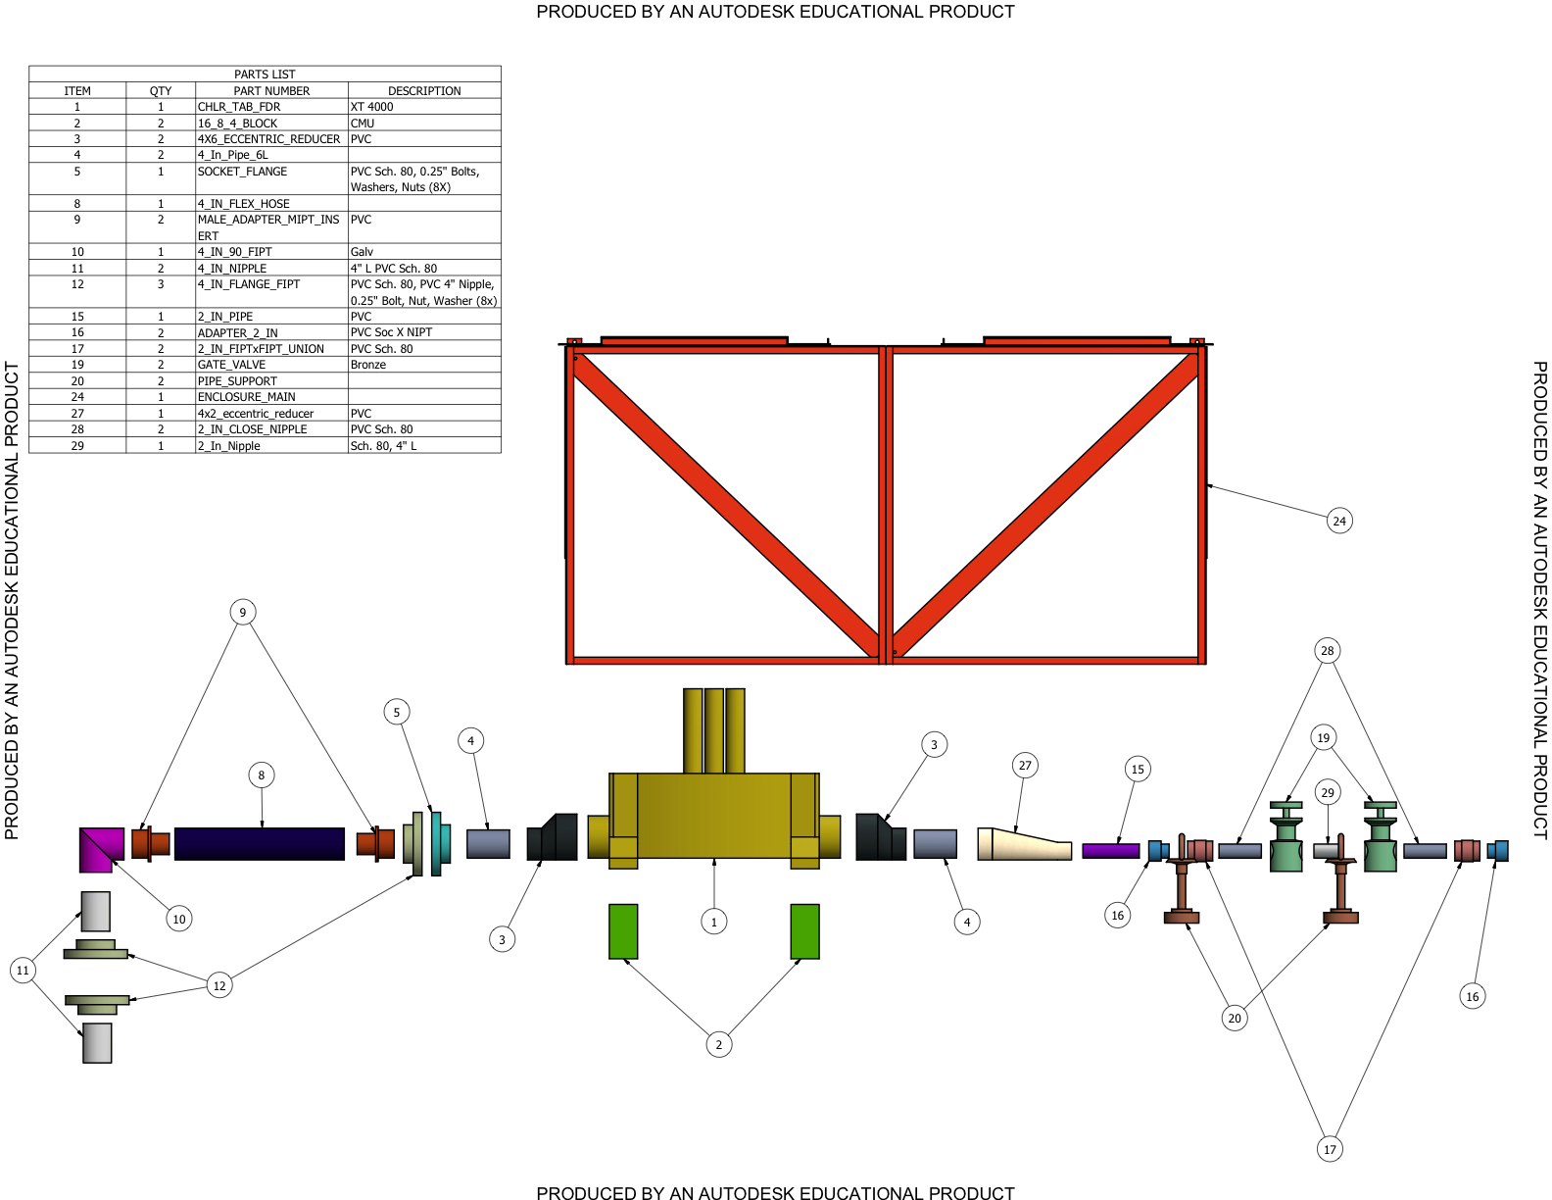

Figure 2. Chlorinator Enclosure Assembly Drawing and BOM

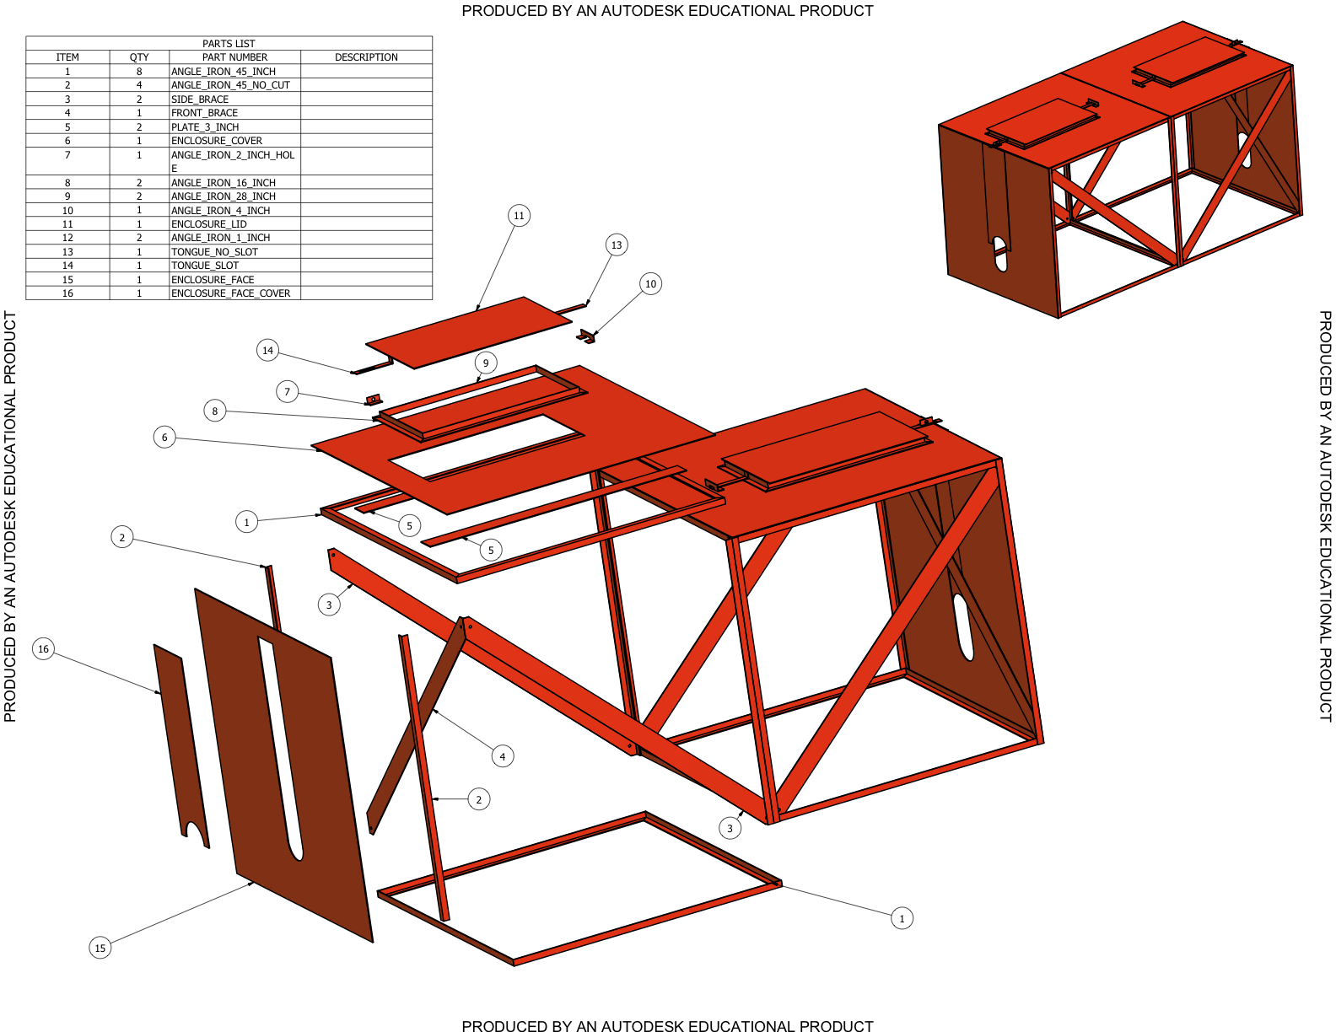

Figure 3. Solids model of chlorinator and enclosure assembly.

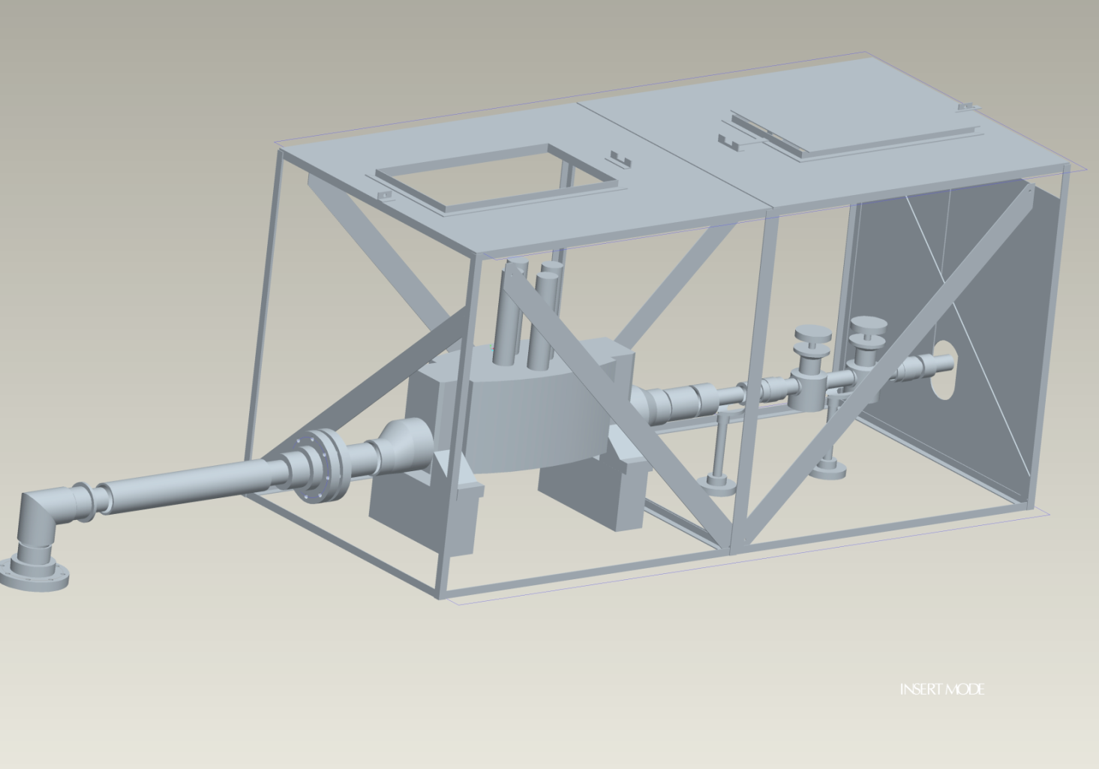

6.0 PHOTO DOCUMENTATION

Photos are included as an Appendix at the end of this report.

9.0 NEXT PHASE OF THE PROGRAM

The next phase of the program will shift more focus on sustainability of the improved water infrastructure in Les Anglais through formal training in technical and financial management. The project will continue to negotiate a partnership with Sofitraining and IFC-World Bank to provide financial management training to the water boards. It is anticipated that this training will also include recruitment of new people in Les Anglais with the right skill mix and willingness to learn, to participate in management and oversight of the water system.

The technical training will focus on development of improved capacity to measure system performance and be able to act on the data to improve performance. The project will explore possible development of user surveys to establish a baseline for water system operation from a user perspective, somewhat analogous to the baseline community health assessment established by the team in 2009.

It is anticipated that while capacity building is ongoing the project will design and install a chlorinator on the Caiman line and follow-up with training and capacity building for the Caiman water boards and operators.

Appendix A: Photo Documentation

Figure A1. Local volunteers and EWB and Tout Bagay team members install chlorinator enclosure on top of Basin Simbe reservoir.

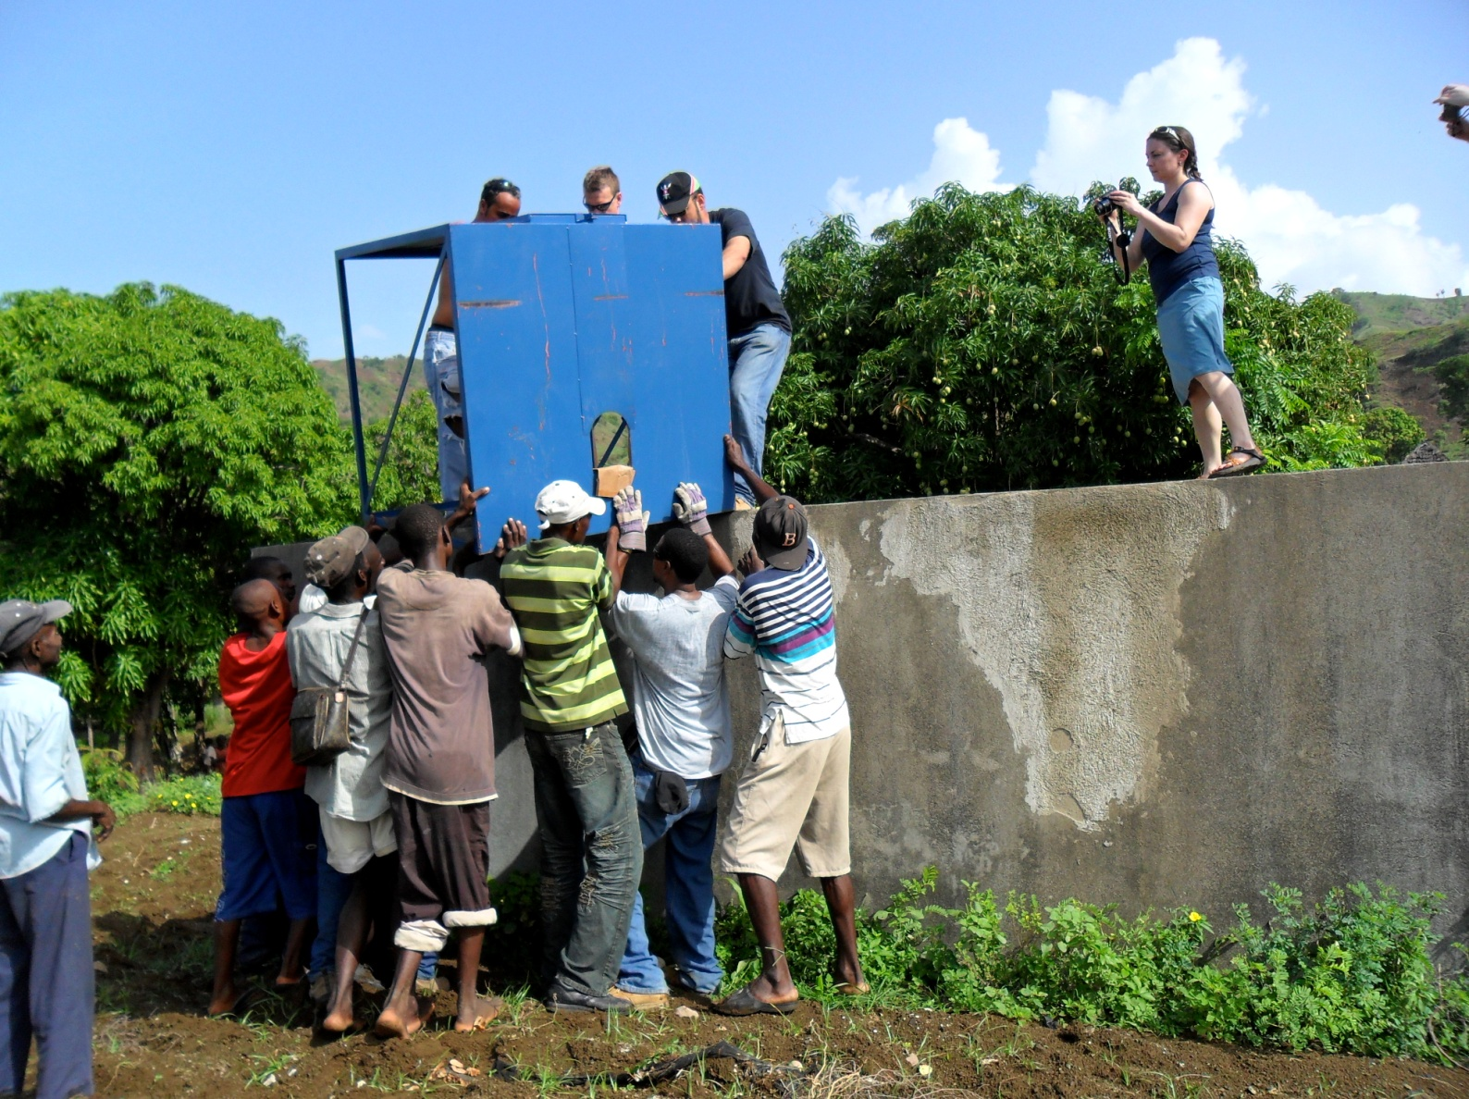

Figure A2. Chlorinator Enclosure prior to chlorinator installation.

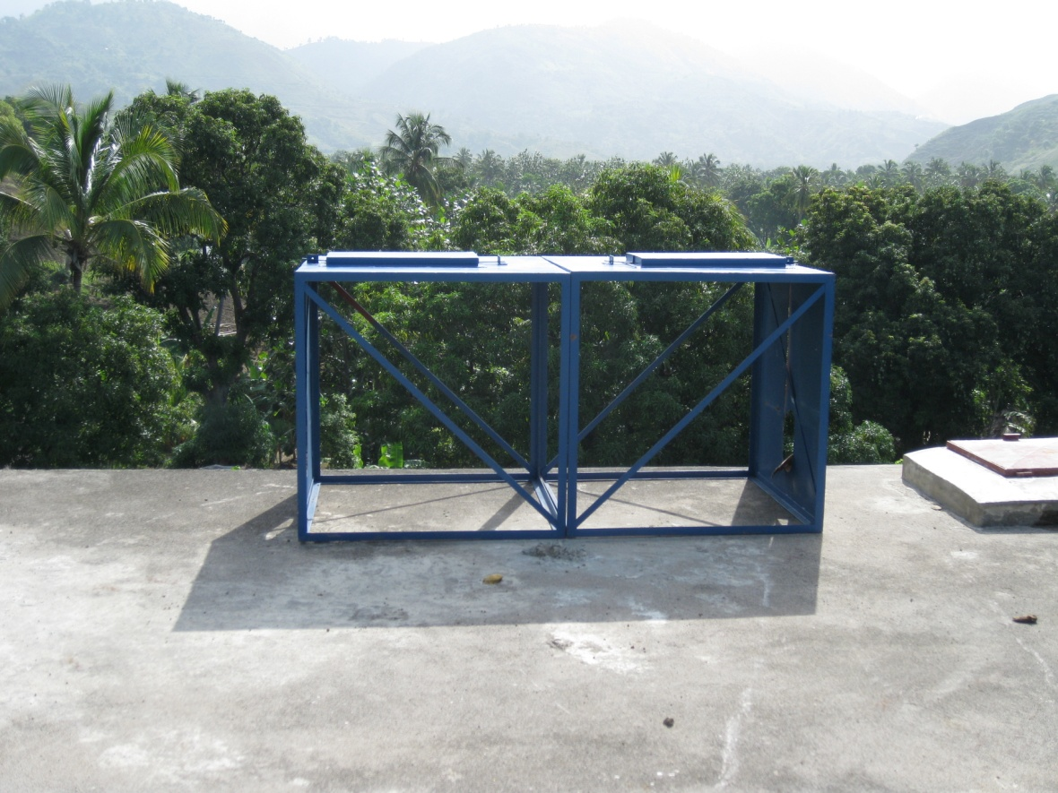

Figure A2. Travis Hultin, EWB, and Laurent Auguste, Tout Bagay, work on chlorinator installation on top of reservoir.

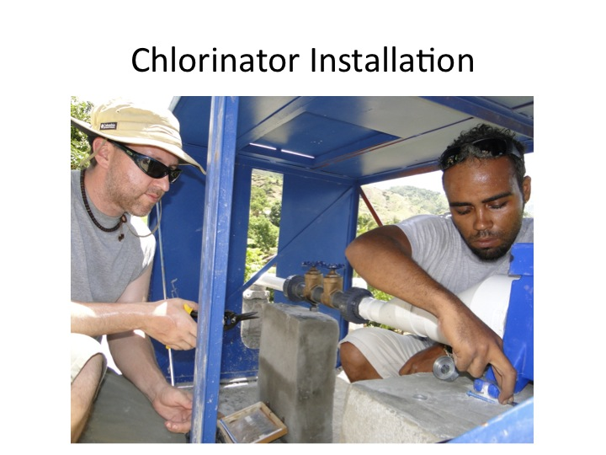

Figure A4. Matt Hewitt, EWB, stands next to installed chlorinator system.

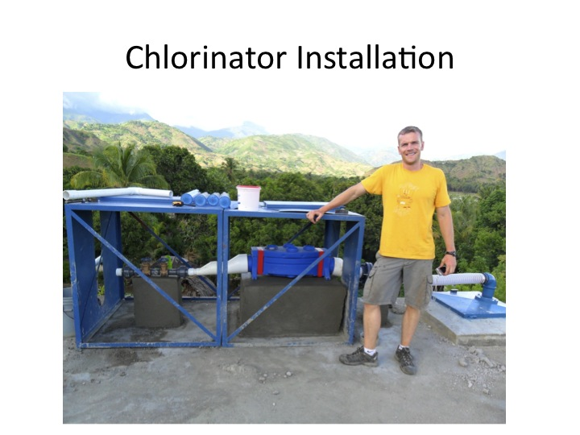

Figure A5. Kim Slack, EWB, trains new chlorinator operators.

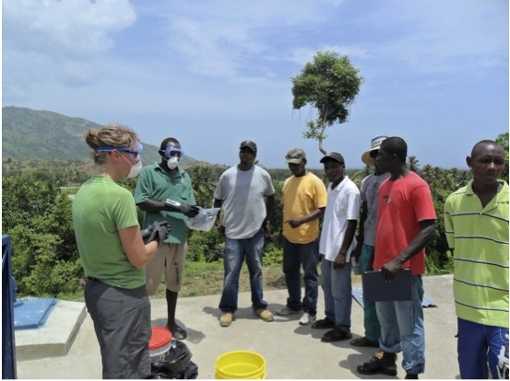

Figure A6. Edouard Lovelace, Tout Bagay, explains operation of chlorinator weir to M. Laurent, Basin Simbe plumber, and new chlorinator operators.

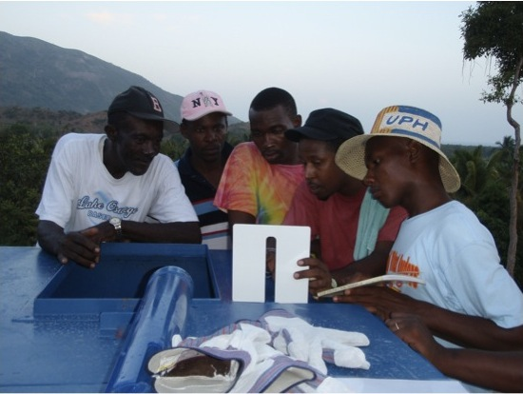

Figure A7. Michealle Fortune, Sofitraining, conducts scoping meeting with water boards for financial management training in Les Anglais.

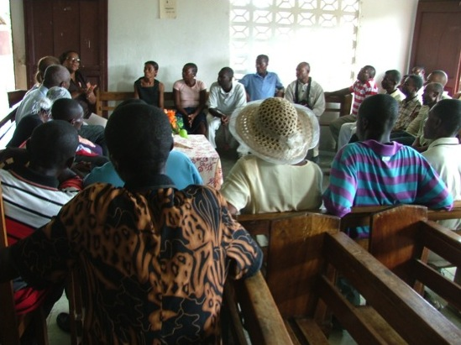

Figure A8. Haitian partners from Port-au-Prince and Les Anglais in front of completed chlorinator installation.

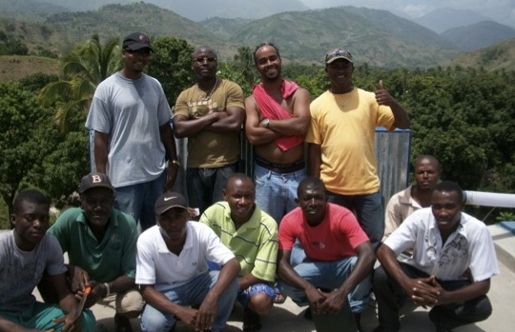

Figure A9. EWB June 2010 travel team in front of completed chlorinator installation.



